MCG2101 – Intro Design of MCG Systems

Deliverable 7
Group 13

Names:
Haneen Barghouti
Lara Al Nakeeb
Emma Cochran
Linh Nguyen
Toshio Woo

Table of Contents:
1. Summary 3
2. Introduction 6
3. Design Description and Rationale 7
3.1 Locomotion 7
3.2 Sampling Mechanism 11
3.3 Buoyancy System 17
3.4 Structure and Wear Resistance 19
3.5 Stability System 22
3.6 Full Assembly 25
4. Design Ensemble 28
4.1 Locomotion 28
4.2 Sampling Mechanism 30
4.3 Buoyancy System 32
4.4 Structure and Wear Resistance 33
4.5 Stability System 34
5. Conclusion 36

List of Figures:
Figure 1. Locomotion assembly shown inside the crab shell 7
Figure 2. Turning mechanism 8
Figure 3. Close-up of spring actuated opening mechanism (turning mechanism) 8
Figure 4. Klann mechanism simulation with footpath 9
Figure 5. Single-sided Klann linkage 10
Figure 6. Section view of extended sampling mechanism 10
Figure 7. Full view of the sampling mechanism while retracted 11
Figure 8. Full view of the buoyancy system at mid compression 16
Figure 9. Isometric View of Crab Shell 18
Figure 10. Side View of Crab Shell 20
Figure 11. Bottom Portion of Footpad 22
Figure 12. Full Footpad Assembly 23
Figure 13. View of the Fully Assembled Spy Crab 24
Figure 14. Top View of the Full Assembled Spy Crab with Top Case removed 26
Figure 15. Drawing of Assembled Spy Crab 27

Summary

This report presents the final design and development of a mechanically actuated spy crab robot intended for underwater monitoring and exploration of European Green Crabs in the Gulf of St. Lawrence due to their invasive and aggressive behaviours. The objective of the project was to create a compact, stable, and environmentally compatible device capable of operating in benthic environments while minimizing disturbance to marine ecosystems. The primary design requirements include crab-like locomotion, the ability to traverse irregular terrain, resistance to corrosion, and integration of a sampling mechanism for data collection.
The final design is composed of five primary subsystems: a Klann linkage-based locomotion system, a sediment sampling mechanism, a variable buoyancy system, a protective outer shell, and stability foot pads. In the final design, a motor-driven belt and shaft transmission was implemented to drive all eight crab legs, which enable coordinated lateral movement. The sampling mechanism utilizes an Archimedes screw to collect and store sediment with minimal environmental disruption. It also includes a piston-driven buoyancy system that allows for controlled vertical motion and contributes to system stability and self-rightening capability. The design has structural integrity and durability through the use of corrosion resistant materials such as HDPE, stainless steel, titanium alloys, and acetal polymers.
The integration and collaboration of these subsystems results in a mechanically feasible and functional design that satisfies the project constraints. The design demonstrates the ability to navigate complex seabed environments, collect environmental data, and operate reliably under underwater conditions. Although future refinement is required for manufacturing and assembly optimization, the proposed design provides a viable solution for minimally invasive monitoring. The final design supports ecological impact of the European Green crab and advancements to marine life research.

Introduction
The purpose of this project was to design a mechanically feasible spy crab robot for underwater exploration of the Gulf of St. Lawrence and the invasive European green crab species that inhabits it. This species of crab has become a concern to the native marine habitats. It damages eelgrass beds, shellfish populations, and sediment structures. Monitoring methods that currently exist can be damaging and disruptive to biodiversity, or they do not provide the necessary observation equipment. There is the need for a more terrain adaptable and minimally invasive device capable of operating directly on the seabed of the Gulf of St. Lawrence to support observation and sampling.
To address this and create a robot crab which meets these criteria, the final concept integrates a Klann linkage locomotion system, a buoyancy system, a sampling mechanism, an outer shell structure to protect these internal components and a stability footpad system. These systems were developed keeping in mind the goals of the robot crab, structural integration, and its operation in an underwater environment.
This report presents the final design and the rationale behind the various design decisions made for each subsystem. It explains how the robot was developed to satisfy the client’s requirements related to locomotion matching that of a crab, stability, environmental interaction and feasibility underwater while considering the assemble and sizing constraints. The report also demonstrates the integration of the components and how they work together as one mechanical system to create a functional crab-inspired spy robot.

Design Description and Rationale

Locomotion
The design of the locomotion system consists of three interacting components to move the rotary power of one motor to a belt and shaft then to a Klann linkage and rotation mechanism that allows lateral motion and rotation of the crab.
The power starts at a 728-300 – 28mm Brushless Motor which provides 55mNm of torque [1]. This motor was chosen for its torque-to-size ratio and its low cost. To determine the required motor torque, force calculations based on the weight and linkage length were performed and evaluated at 52mNm. To conserve internal space, the motor was placed at the back of the crab, which accommodates the motor with a casing compartment to prevent the motor from being exposed. The back placement also allows simplifies power transmission by eliminating any need for bevel gears and minimizing the number of rotation axes. The one restriction with this motor is that its no load speed is 2120 rpm [1]. To lower the speed, a smaller voltage drop and a two-stage 50:1 speed ratio gear train was used.
From the motor, the rotation is then transferred to a belt and shaft system consisting of three shafts and six belts. This system minimizes interference with the internal buoyancy and sampling subsystems and allows the efficient transfer of power from the motor to the Klann linkage. As seen in Figure 1, the central motor shaft contacts the two rear belts; the first rear belt drives the first rear Klann linkage, and the second belt drives the second Klann linkage while also meshing with the outer shafts. Between the second and third belt, there is a turning mechanism which allows the front legs to move in the opposite direction of the back legs. The third and fourth belts both rest on the outer shafts meshing with the front two legs. In order to allow smooth rotation of the outer shafts, there are bearings housed in the shell walls. To prevent degradation of the belt and shaft system, the shafts material was chosen to be Delrin and the belts were chosen to be TPU. Both these materials are lightweight, water resistant, high fatigue strength, affordable materials that are particularly suited to their purpose [2], [3]. While there are holes in the shell to allow belts to pass through, each hole is accompanied by rubber rollers which slightly compress the belts, and brushes which reduce the water flow to the holes. Together, these components reduce the permeability of the shell, greatly decreasing the likelihood of water entering the shell.
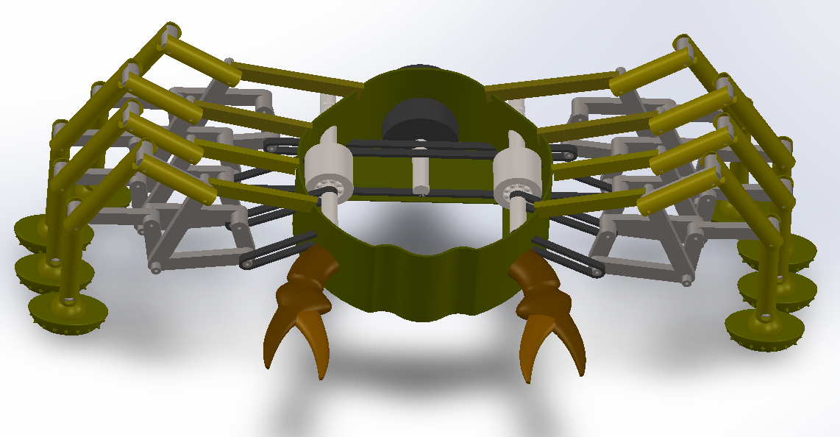
Figure 1. Locomotion assembly shown inside the crab shell

The turning mechanism allows the crab to turn by reversing the shaft’s direction of rotation for the front two belts, providing a moment on the front and back legs. In order to minimize the electrical components, a mechanism that employs centripetal and spring forces was used. This mechanism has two states: closed and open. In the closed state, the pins (highlighted in blue) are in contact with the input and output shaft, closer to the axis of revolution. In this state, the pins directly transmit the rotation between the two shafts making them rotate in the same direction. In the open state, the pins move outward, meshing with the input shaft and the output shaft’s orbit gear. The orbit is the outermost ring in a planetary gearset where the output shaft is the sun. By engaging the orbit gear, the rotation of the output shaft is reversed from the rotation of the input shaft. The transfer between the open and closed states is determined by the centripetal force overcoming the competing spring forces. Figure 2 displays the planetary gear shell in its open state where the top spring is compressed by the centripetal force allowing the tension spring to retract, opening the gap for the pins to move outward. The required RPM for this transition to occur is constant and stable as the wall will only open if the centripetal force is higher than that of the springs. For a spring with spring constant 3kN/m, the required rotational velocity is 224rpm, determined by the force balance on the door and the openier

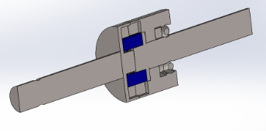
Figure 2. Turning mechanism
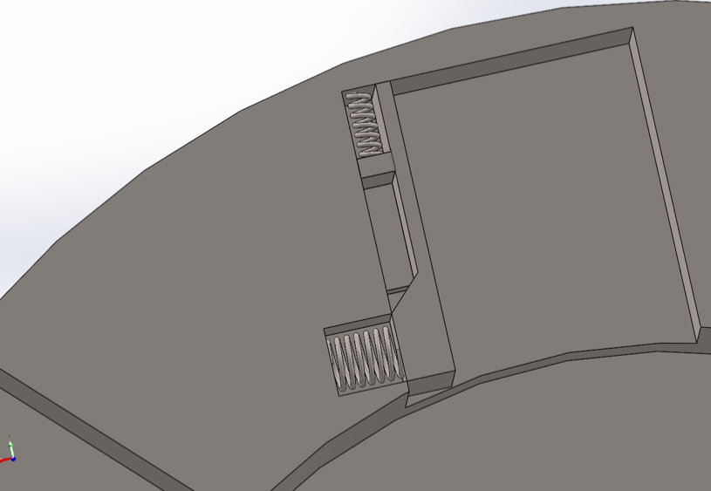
Figure 3. Close-up of spring actuated opening mechanism (turning mechanism)
The final component of the locomotion subsystem is the Klann linkage. The single-sided Klann linkage variation converts the rotary motion from the belts into a triangular footpath of the bottom linkage allowing the crab to contact and push off the sea floor. Each of the linkages are joined by a pin and bearing system to reduce wear and increase smooth rotation. Because the Klann linkage is the most exposed component of the entire design, a durable material was needed leading to the selection of Ti-6Al-4V. This material has very high wear resistance and corrosion resistance ensuring the locomotion system does not deteriorate after multiple uses. Its higher weight relative to the crab body structures also contributes to a lower centre of mass, reducing the likelihood of the crab flipping over. With these properties being critical to the crab’s performance, the cost of the titanium alloy was justified. The simple geometry of the Klann linkage components would facilitate CNC machining.
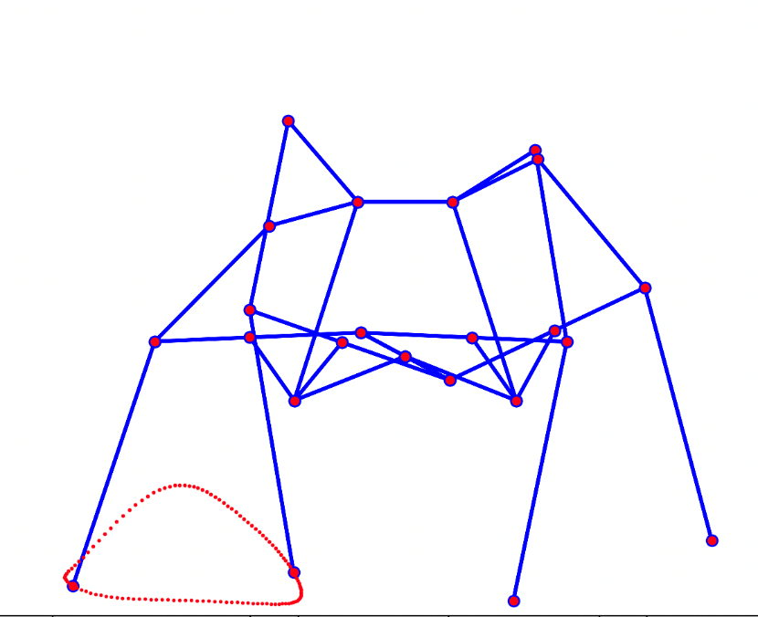
Figure 4. Klann mechanism simulation with footpath
(Note: single-sided linkage used in product)
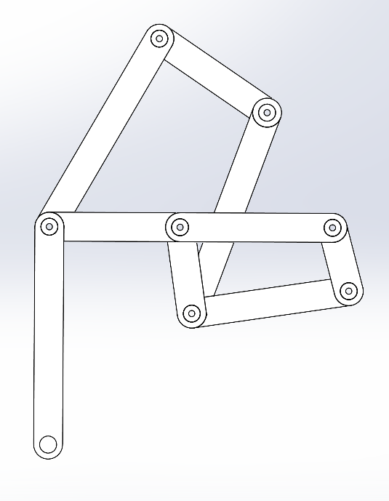
Figure 5. Single-sided Klann linkage

Sampling Mechanism
The goal of the sampling mechanism was to collect sediment samples from the riverbed. Sediment was chosen as the sample to be collected since organic matter can give clues to what the crabs are eating, be used to measure contaminants and pollution, identify and map the sediment type they prefer and are likely to invade, and monitor how the habitat changes as these invasive crabs move in. Some important considerations when designing this mechanism included minimizing the number of motors used, adapting to the underwater environment, and minimizing its size and its components complexity. A section view of the mechanism can be seen in Figure 6 below.
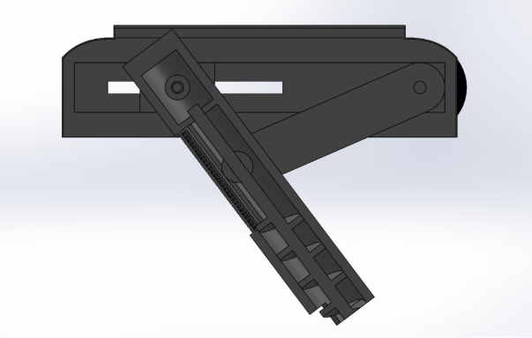
Figure 6. Section view of extended sampling mechanism
The main component of this system is the Archimedes screw inside the cylinder. As it turns, it will collect sediment in the upper chamber. An angled cut was made in the side of the cylinder to allow sediment to enter. As it continues to rotate and collect more sediment, the sediment already in the chamber will be compressed, squeezing out excess water through the filter in the side of the cylinder. The chosen filter is a 500 µm stainless steel mesh, which would be removable to allow access to the collected sample and for cleaning. The cylinder is raised and lowered using a sliding linkage mechanism. As the motor shaft turns, the two mirrored bars on the shaft will move the cylinder with them. There are bearings connecting the bars to the cylinder, allowing it to rotate smoothly. Through the top of the cylinder is the secondary shaft, attached to the sliders within the casing, again with bearings. This allows the cylinder to move horizontally, while preventing vertical movement.
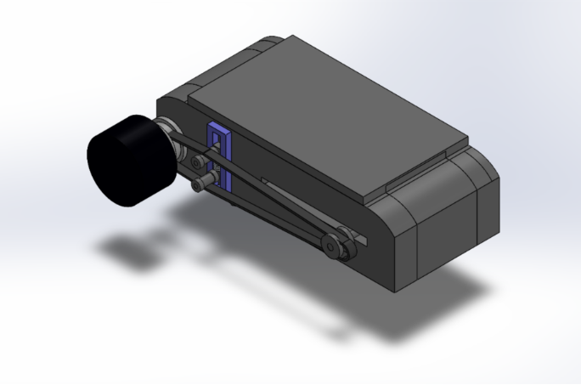
Figure 7. Full view of the sampling mechanism while retracted
Attached to the motor shaft is a pulley and belt system, which can be seen in Figure 7 above. The belt connects to another pulley on the secondary shaft, allowing both shafts to turn using only one motor. Attached to the casing is spring tensioner with two rollers to keep the belt taut as it moves back and forth along the slit cut into one side of the case. The rotation of the secondary shaft is translated to the screw shaft using a pair of bevel gears, one on the secondary shaft and another on the screw shaft. The whole mechanism is powered by a servomotor to allow precise control of its movement, and since the motor shaft cannot rotate a full 360 degrees without the cylinder colliding with the secondary shaft. Due to its inability to complete a full turn, the power transmission to the screw requires a gear ratio that increases the RPM. Along the system, the pulleys and gears get smaller, allowing the screw to spin at a higher RPM than the motor shaft, at the sacrifice of torque, so that the screw can complete multiple rotations before the motor shaft reaches its limit. The sacrificed torque was determined to be acceptable as the sediment is light and the amount sampled relatively small, requiring minimal force. This gear ratio will need to be quite high to allow the screw to pick up enough sediment. It was estimated that approximately 6 full rotations of the screw would be necessary to fill the cylinder, while the linkage bars should descend no more than an eighth of a rotation past floor contact (at approximately 45 degrees) while doing so. To accomplish this, a gear ratio of approximately 1:48 is required between the pulley and bevel gears. This can technically be accomplished with the current configuration, but in reality, this would require such a small secondary pulley and gear teeth, the belt would slip, the teeth would wear, and energy would be lost due to inefficiencies. A better setup would involve a worm gear, or a planetary gear to allow the bevel gears to keep a 1:1 ratio and minimize the other issues.
The screw was chosen for its simplicity since it allows the sediment to be collected with essentially just two movements, the turning of screw and its extension/retraction motion. The sliding mechanism was again chosen for simplicity, and based on a Scott-Russel linkage, though the dimensions were altered so the cylinder’s end no longer moves straight up and down. The chosen linkage allows two points of connection, necessary for extra security in the river’s current. The linkage bars and sliders were also mirrored for symmetry, balance, and extra security. The belt drive was chosen to transmit power from the motor shaft to the secondary shaft with minimal parts compared to a long gear drive alternative. Despite gears not having some belt disadvantages like stretching or slipping, a belt was chosen to minimize potential points of failure with fewer parts. The belt was also chosen over a chain because the rubber belt will not rust or corrode like metal and is naturally water resistant. Additionally, a belt would be quieter than both other options and less likely to disturb nearby wildlife.
The 500 µm stainless steel mesh was chosen due to its strength, necessary as the sediment will be compressed against it, its durability, and saltwater corrosion resistance. A strong nylon mesh is another option as it is cheaper and lighter but was not chosen as it would be weaker and more likely to tear, could stretch and loose shape, and is less durable. For the pair of bevel gears, the larger gear attached to the shaft will be brass and the gear on the screw shaft will be Delrin, a brand of an acetyl homopolymer. In this system there is very limited space and a high output speed is desired, so materials with low friction and energy loss are required, especially since bevel gears are particularly susceptible to energy loss. Ideally there is also low wear to maximize lifetime and minimize need for repair. The brass will resist wearing well, and the Delrin will be lightweight and minimize friction eliminate the need for lubrication as would be in the case of two metal gears [1]. While the high speeds may create heat and Delrin has a lower melting temperature than metals since it’s a polymer, this was deemed negligible since the machine will be operating in a cool underwater environment, and the sampling mechanism will not be operating continuously for long periods of time.
The casing was chosen to be made of high-density polyethylene due to its durability, low weight, and saltwater corrosion resistance. The motor shaft, secondary shaft, and screw are to be made of 316 stainless steel for its high strength and corrosion resistance [2]. Steel was chosen over other metal options such as aluminum or titanium. Aluminum was not chosen because it is weaker and more susceptible to corrosion. Titanium was not chosen because of its higher cost and higher machining difficulty. The bearings will be sealed ball bearings to avoid water leakage. To avoid water entering the system, the cylinder and slider portion will be sealed off from the rest of the body by the casing. In the gap in the casing for the sliding secondary shaft, a flexible membrane will be used to keep water out from the rest of the mechanism and will slide with the cylinder. Rubber seals and gaskets will be used at connection points, such as the interface between the casing and the main body.
The critical shear stress of sediment in along the clay banks of the St. Lawrence River is approximately 6-20 Pa [4]. To account for variation in sediment strength, a shear strength of 100 kPa was used as most river sediments should be below this value [5]. The required torque was calculated using this strength value and the radius of the screw.
$$A=πr^{2}=7.8540×{10}^{-5} m^{2}$$
$$F=τ×A=7.8540 N$$
$$T=F×r=0.03927 N∙m$$
A DC servomotor, 5082N33 from McMaster-Carr, was chosen as the motor for the sampling mechanism [6]. It has a continuous torque of 21.2 in·lbf, or 2.40 N·m. To account for the gear ratio, the torque the screw will receive will be this value divided by 48, or approximately 0.05 N·m which is above the 0.04 N·m calculated using a high sediment strength, over a thousand times the reported for the St. Lawrence clay banks [4], [6]. It was also chosen because it has a height of 80 mm, the smallest height found for a motor of the required torque, and which fits in the lower section of the crab [6]. The main downside of this motor is its high cost, which makes sense given its small size. In general, this mechanism would be expensive to produce as most components are smaller than standard size resulting in higher manufacturing difficulty, time, and cost.
The main area for improvement of this design is adapting it for realistic manufacturing and assembly, including adding mounts and boreholes to attach each part. This was largely neglected aside from verifying that bearings, gears, and motors of the desired size existed. Overall, the design offers a relatively simple, compact, and robust mechanism to collect valuable sediment samples useful for studying this invasive species.

Buoyancy System

The buoyancy subsystem was designed to allow the spy crab to have precise vertical control and use minimal energy consumption. This system’s main components include: an air chamber, piston, linkage, and motor; these components sit in the upper half of the crab shell; all together they allow the crab to float and ascent/decent.
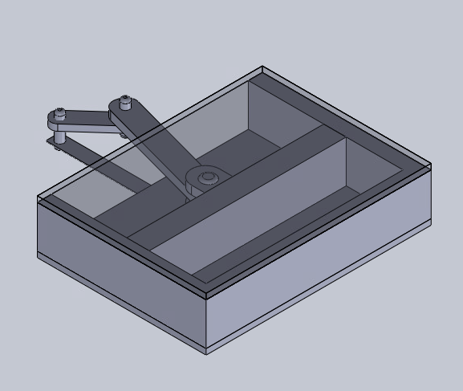
Figure 8. Full view of the buoyancy system at mid compression
The buoyancy system was developed by creating an inner chamber filled with air. The air within this chamber is compressed and expanded by a piston arm. The piston arm is the primary separator of the air and the water that exits and enters the crab accordingly. This mechanism was chosen since the crab is relatively small and has little interior space. The density needed to change to allow the crab to rise and sink. After many concepts and ideas, it was determined that the best way to adjust the crab density was through displacing water and compressing air. It was important for the system to be reusable; this eliminated the option of using weights that would be dropped and any type of chamber that fully releases the air.
To ensure the water does not leak into the air chamber, a U-cup thermoplastic seal was chosen due to its ability to operate at lower temperatures. It was also the best choice since it creates a tight seal that is wear resistant and easily replaceable in the case of wear and tear. Another important factor that was considered while designing the buoyancy system was that the crab must minimally disturb the environment. By designing the buoyancy system to sit inside the shell of the crab it reduces the effect of the buoyancy system on the environment. The small hole in the crab shell also allows the water to enter and exit without disturbance to marine life and Gulf beds, which fulfills the minimal disturbance section of the mandate.
In the final buoyancy system design, the piston is driven by a motor. This was the most effective way to drive the piston since there is limited interior space. A brushed DC spur gear motor, SDS1427, was selected due to its small size, light weight, rotations per minute, and high quality [9]. The crank and slider mechanism were chosen to allow the rotational motion of the motor to be converted into linear. This mechanism was the best choice as it uses the least amount of material and takes up the least amount of space. Therefore, it optimizes the weight and internal space of the crab.
Final small details include a straw-like tube to separate water path and keep the interior of the crab dry (allows the motors to last longer). Another small detail includes fillets to the exterior corners of the chamber to reduce space and reduce potential shell interference. This fillet allows other components to take up more space as the buoyancy system will sit flusher with the shell.
The buoyancy system is designed to be manufactured from Acetal (polyoxymethylene or POM) homopolymer Delrin AF DE588, due to its dimensional stability, low moisture absorption, and ease of machining [10]. This specific material also has excellent wear properties in both wet and dry environments and is used in various sea equipment. Acetal has excellent machineability while decreasing cost and likeliness of defects. This material is chemically resistant to solvents and chemicals, while having strong and stiff performance characteristics [10]. This thermoplastic material is to be manufactured by injection molding for the casing and CNC machining for the piston, linkage, and motor mount [11].
The final buoyancy system design fits the criteria of the spy crab and allows the crab to be easily deployed and retrieved in the case of an emergency. The strategic placement within the crab shell ensures the crab will be reoriented, in the case of inversion due to the current. The buoyancy system works well with the other subsystems and allows for a functional crab that can thrive in the Gulf of St. Lawrence.

Structure and Wear Resistance

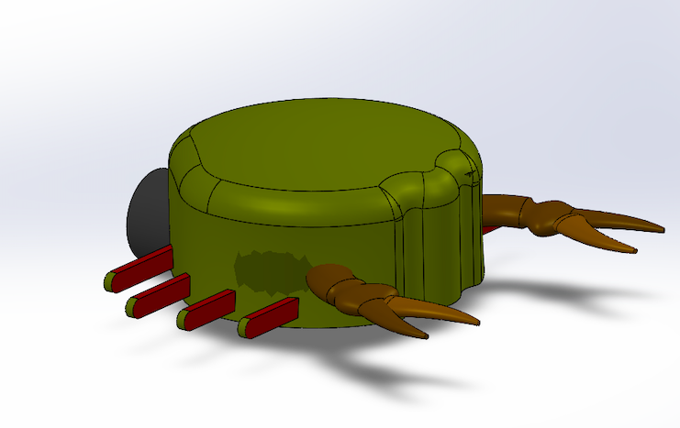
Figure 9. Isometric View of Crab Shell
The outer shell subassembly was designed to function as the primary structure to protect the internal components and motors of the crab system. Its main purpose is to protect the internal components while also as the mounting platform for the leg Klann linkage mechanisms. The design was made to prioritize structural integrity, weight efficiency and compatibility with moving linkages, while also taking into account the pressure it will undergo once placed underwater.
The geometry of the shell was developed using a curved, domelike structure. This shape was chosen for the design as it helps distribute external loads more evenly among the crab in comparison to flat surfaces. This helps improve the resistance to deformation under pressure. The curved profile the shell offers helps reduce drag within fluids, which makes it more efficient while in motion underwater. The smooth exterior was designed to help minimize stress concentrations and potential impact damage if struck by anything underwater.
In order to attach the leg Klann linkage mechanism onto the shell, extruded rods were incorporated into the design. These rods act as mounting regions between the shell and linkages. This design was picked over attaching the linkages directing onto the surface of the shell as it provides better load distribution and doesn’t cause any interference or hinder the motion of the linkages by colliding with the outer surface of the shell. Belts have also been added to the design as they help transmit motion to the linkages from the motor. Upon the entry of the crab there is a brush wiper and rubber hybrid seal designed to minimize water entry into the crab.
The placement of the mounting points was designed with symmetry and balance. Equal spacing between the attachments was ensured to maintain consistent load transfer and stability while in motion. Clearance between the mounting points was added to allow for full range of motion with any inference or overlapping. In order to further minimize water entry, rubber gaskets were installed between the inner and outer shell and tolerances were set to an interference fit for the rubber to form a full pressure seal upon closing of the crab.
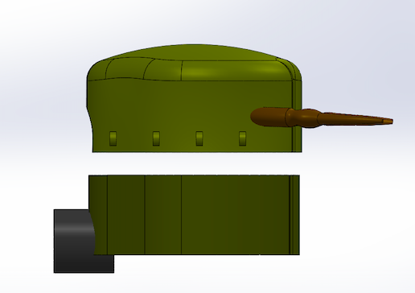
Figure 10. Side View of Crab Shell
On the inside of the shell structure there is sufficient space to accommodate the mechanical components while maintaining the compact design of the shell. Space was created for the buoyancy system, sampling mechanism and the motors that help move the linkages and the buoyancy system and sampling mechanisms.
The material selected for the shell was chosen while taking into consideration the environment it is going to be placed in and its mechanical design. HDPE (High-Density Polyethylene) was chosen as it has great resistance to corrosion, especially in saltwater conditions, as the Gulf of Saint Lawrence is not fresh water but rather saltwater. It is also durable and lightweight which would help make the crab more evenly weighted as the leg mechanism is made of titanium. Compared to metals, HDPE does not rust and does not require significant maintenance which makes it a good choice for use in long term activities without having to worry about maintaining it.
As the material chosen is HDPE, it opens up the opportunities to several different fabrication methods. For this specific design, the shell could be manufactured using CNC machining from an HDPE block, which helps provide accurate dimensioning and helps provide smooth surfaces which fit within the curved geometry design of the shell. Using this method of production, it helps precise control over the mounting holes and extruded rods. However, this method is ideal for small scale production. If larger scale production is required, processes such as injection molding could be used to produce the curved shell design. As the geometry of the shell isn’t complex, it makes it simpler to produce using any method. Overall, the selected geometry and material ensure that the shell can be easily manufactured while balancing costs.
Overall, the shell assembly was designed with the priority of protecting the internal components and providing structural support. The design decisions considered were made to ensure durability, consistent load transfer and smooth operation as the crab is underwater.

Stability System
The stability system of our crab is a footpad attached to the end of each leg. It was designed to increase stability, traction and adaptability to the benthic terrain during locomotion. Given that the robot will operate on the seabed of the Gulf of St. Lawrence which may be uneven, sandy or rocky, maintaining consistent ground contact was a very important goal. This had to be done with the assurance that the added footpad will not interfere with the robot’s locomotion. The final design consists of an oval pad with integrated spikes around its circumference which is mounted by a ball and socket joint to the end of each Klann linkage segment. This configuration was chosen to maximize the robot’s adaptability to the surface while ensuring smooth and unrestricted leg motion.
The oval geometry of the footpad was an improvement on the initial spherical shape. This decision was made to improve directional stability and increase contact area as well as to ensure there is no interference between the adjacent feet during the walking cycle. The longer, thinner design from the oval shape is what allowed us to ensure that the feet would not knock into each other and affect the motion of the Klann linkage. The addition of small spikes around each pad improved traction on both soft sediment and rocky areas but it is still minimally intrusive to the environment. This design balances the need for grip and the requirement of minimizing disturbances to the seabed.
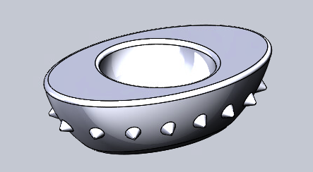
Figure 11. Bottom Portion of Footpad

Another design decision was to attach the footpad to the leg by using a ball and socket joint. This type of connection allows the footpad to self-align with the surface to ensure maximum contact regardless of the terrain type or irregularities. The ball and socket reduce any resistance that the legs may feel during locomotion, allowing them to move freely without any added stress transfer due to resistance from the feet or terrain. This improves the durability of the linkage as well as the efficiency of its motion. The ball and socket joint doubles as a leg shell to go around the linkage to provide protection for the lower leg components from any sediment that may affect the motion.
The mounting strategy was decided on to ensure that the friction pad motion is independent of the main motion of the Klann linkage. By making the rotation at the interface of the leg and the footpad, it does not affect the crab’s locomotion. Ensuring there is no interference is essential to maintain the walking pattern while still allowing the crab to adapt to the terrain. As a result of all the added components, the footpad achieves an effective solution to providing stability, traction and environmental compatibility.
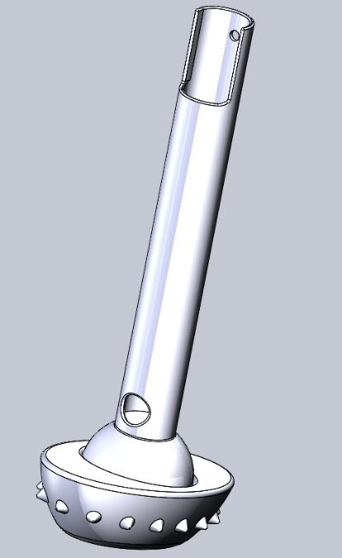
Figure 12. Full Footpad Assembly

The footpad assembly is designed to be manufactured from aluminum due to its low density, corrosion resistance, strength and machinability. Because the crab will operate underwater and attaches to moving systems, minimizing the added weight while still maintaining the structural integrity of the footpads is an important balance to achieve. Aluminum provides a weight advantage to keep the robot grounded and is rigid enough to withstand repeated contact on potentially rocky surfaces. Aluminum was chosen instead of titanium, like for the linkage to minimize the mass of the robot to ensure the buoyancy system will be able to provide enough of a buoyant force on the crab but still ensure the footpad will not wear down quickly. The main body of the pad can be produced using CNC milling from aluminum stock to shape its oval profile and spikes. It also enables a tight enough tolerance to ensure the correct fit for the ball and socket joint and allow for smooth rotation and reliable assembly.

Full Assembly
The design of the full assembly was oriented mostly around space conservation and subsystem interactions. It was developed using five key subsystems, the locomotion system, stability system, buoyancy system, sampling mechanism and the outer shell. Each subsystem was designed with specific considerations in mind. For example, how they interact as a unified mechanical system capable of operating effectively when submerged underwater. Figure 13 shows the crab fully assembled as it would appear in operation.
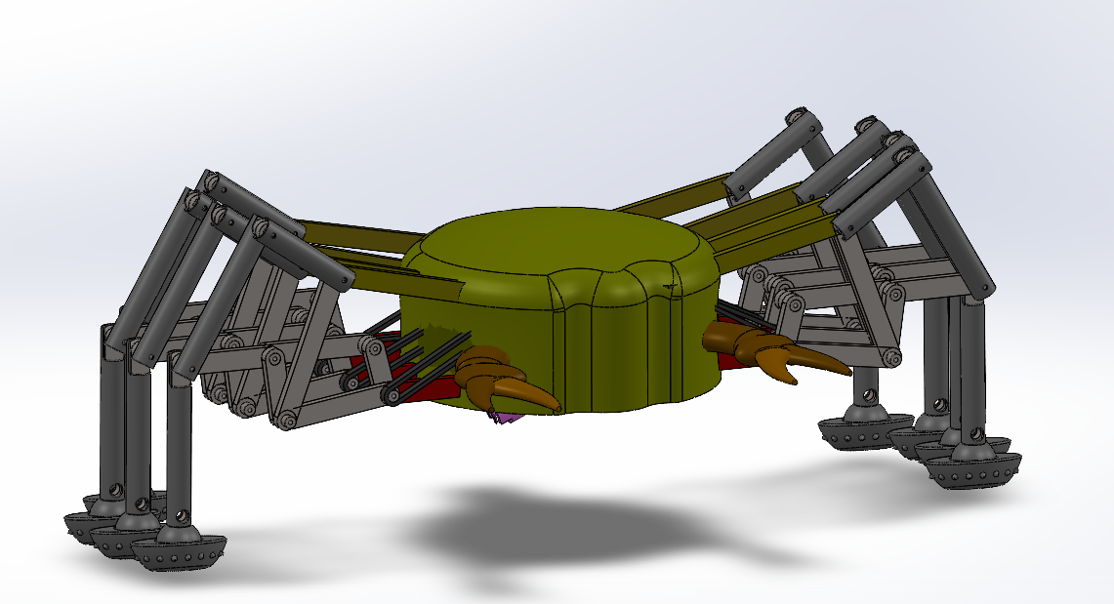
Figure 13. View of the Fully Assembled Spy Crab
The locomotion system is based on multiple linkages assembled to help with contraction and ground interaction. These legs are connected to the main body through connecting rods at the top and bottom of the fixed portions, which act as structural supports. This configuration improves rigidity and reduces misalignment during movement, particularly when transversing uneven terrain. The way the linkages are designed helps with symmetry, ensuring the centre of mass remains low and between the legs.
Connected to the locomotion is the stability system, comprising of eight footpads attached to the ends of each leg. Stability is achieved through coordinated leg movement, a wide stance and proper weight distribution throughout the structure. The mechanical arrangement ensures that multiple legs always remain in contact with the ground, minimizing the risk of tipping. Additionally, the overall geometry of the crab, including its low profile, contributes to maintaining a low center of mass and further enhancing stability during operation.
The buoyancy system is integrated at the top of the crab’s body (Figure 14) with a sealed water-filled chamber which can be compressed to increase the buoyancy. This gives the crab a variable buoyant force that can improve the stability of the crab under different current environments and facilitate the crab returning to its upright configuration should it ever fall over. While the buoyant force from the fully expanded system is not enough to fully overcome the weight of the crab, its placement at the top of the crab further lowers the centre of mass by expelling water from inside the chamber, making it increasingly difficult for the crab to fall over.
The sampling mechanism is positioned at the bottom of the shell assembly (Figure 14) and is designed to interact directly with the environment. A cylindrical arm was designed to extend from an opening in the shell and collect material with a screw, then stored in the cylinder’s upper chamber. This mechanism is designed with adequate clearance from the legs so it does not interfere with the stability or the locomotion of the system, ensuring that the crab can collect the necessary samples.
All these systems are enclosed in the outer shell, which serves as the primary structural and protective component. The shell houses all the internal elements, shields them from the environmental factors such as impact debris and contributes to the overall durability of the system. Its shape also improves the performance by reducing drag and helping resist water currents.
Overall, the full assembly reflects how the crab was designed to fully function as a mechanical system when all components are assembled, the crab’s ability to move, remain stable, resist environmental wear and performing sampling collection tasks. The functioning of these components can be visualized in the assembly drawing in Figure 15.
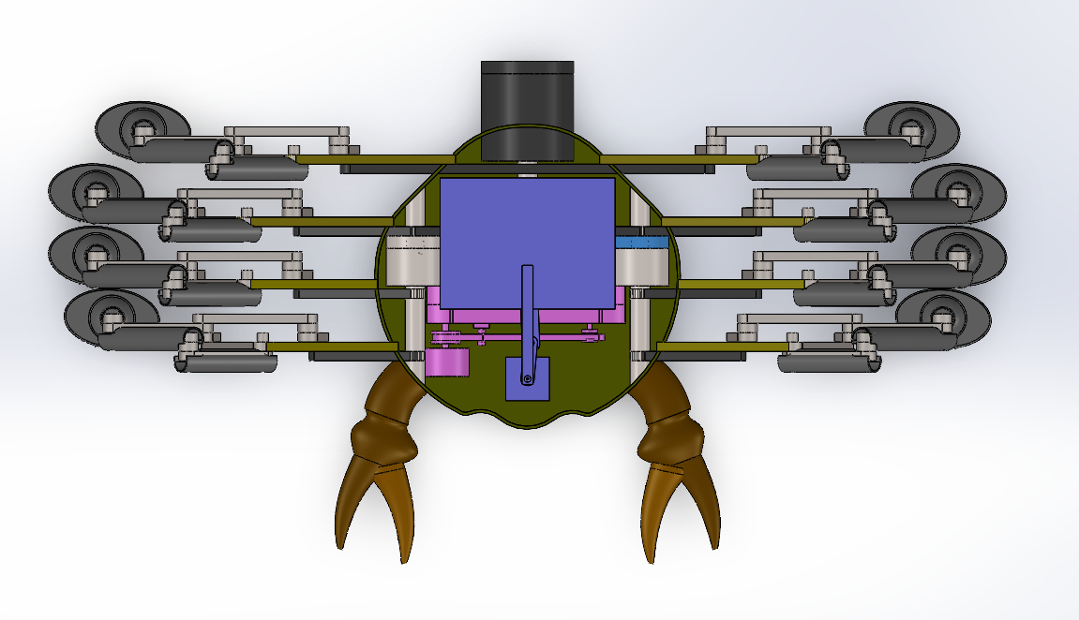
Figure 14. Top View of the Full Assembled Spy Crab with Top Case removed

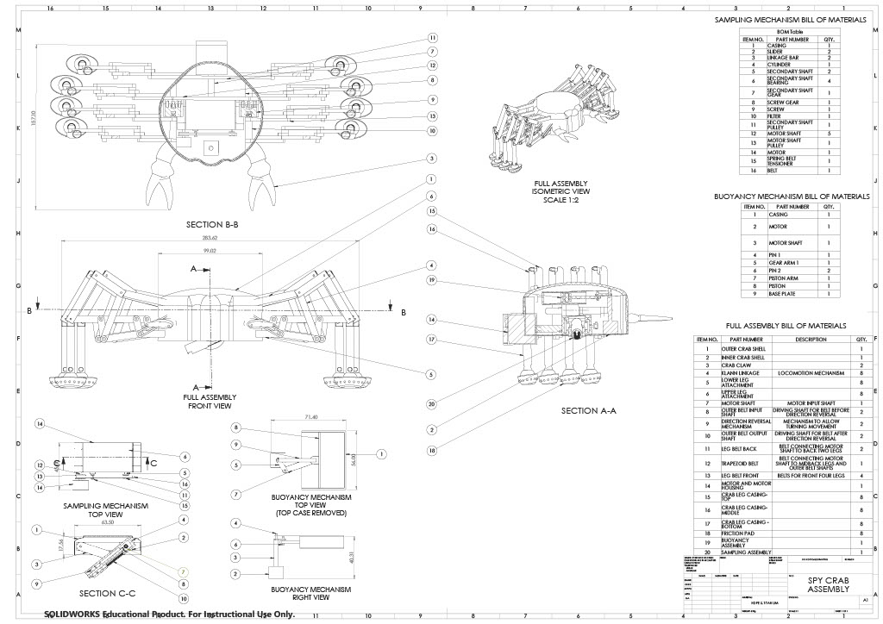
Figure 15. Drawing of Assembled Spy Crab

Design Ensemble

Locomotion
The key design considerations for the locomotion mechanism were that it mimicked the crab’s natural movements, it was compact, and it minimized environmental disturbance. Overall, this led to the selection of a Klann mechanism, driven by a belt and shaft power transmission.
In terms of maximizing crab likeness, the Klann mechanism combined with the turning mechanism and leg casings achieve both natural looks and natural movements. The six-bar Klann linkage has been used extensively as a mechanism for robot walkers and is particularly suited to the criteria of this mandate; not only does the linkage mimic the lateral movement of the European green crab, it also mimics the looks with its three independently moving outer segments. While the Klann mechanism on its own would not be able to turn the crab, the direction reversal mechanism accomplishes this task by employing centripetal force and planetary gears. To further increase the resemblance to the green crab, coloured cylindrical casings were added to these outer leg segments to better approximate the shape and colour of the crab’s legs.
To maximize the compactness and minimize the interference of the legs with other subsystems, two design choices were made: splitting the Klann linkage and using a belt and shaft power transmission. The two applications of Klann mechanisms that were explored in the design process were one-sided Klann linkages and two-sided Klann linkages. While the two-sided Klann linkage used fewer total materials and shafts, it also came with more restrictions to frame placement which ultimately interfered with the internal subsystems; this led to the selection of the one-sided Klann linkage which could be placed in areas that were not being used by other subsystems. The decision to use belt drives naturally followed from the decision to use single-sided Klann linkages. In a similar way to the single-sided linkage, the belts offered very few placement restrictions, meaning they could be placed away from the centre of the crab which was being used for the buoyancy and sampling subsystems.
On top of resemblance and compactness, the locomotion mechanism has also been optimized for the low environmental disturbance criteria. In order to design for this criteria, two factors were considered: impact force and stability. One of the benefits of the Klann linkage is that its path is determined by the length of the bars and can be altered for different purposes. The path for this Klann mechanism was tuned to have a low ground impact angle and a longer contact duration. These features ensure the feet do not strike the ground too hard and that the crab does not fall over while in motion.

Sampling Mechanism
The purpose of this project given in the project description included gathering “in-situ information about the behavior of Green crabs” such as “ecosystem disruptions (e.g., damaging eelgrass or other biological species), reproduction, food diets, and migration patterns” [7]. The sampling mechanism helps meet these needs by collecting sediment that can offer this valuable information. The sediment collected will contain biological material, such as algae or small aquatic invertebrates, that can give clues as to what the crabs are eating in that location. It may also collect their plankton larvae that freely float in the water after they hatch from eggs carried by their mother [8]. This can give valuable information about their reproductive cycle and identify where these crabs have infiltrated. The sediment collected can also be used to help map the riverbed conditions like sand content or aquatic plant life presence. Since these crabs live in shallow water with muddy, sandy, or pebbly riverbeds with plant life like eelgrass, mapping these conditions could help identify where they are most likely to spread to next [8]. It can additionally offer information on contaminants and pollution and monitor how the habitat changes with the arrival of this invasive species.
Other requirements listed in the project description included operation in a submerged marine environment, resistance to corrosion and material degradation, mechanical robustness and redundancy, minimal disturbance of sediment and surrounding organisms, and compatibility with conventional manufacturing processes available in Canada [7].
This mechanism meets the marine operation, corrosion, and degradation requirements by being made of durable, waterproof, and saltwater corrosion resistant materials such as HDPE and 316 stainless steels. Additionally, excess water collected through the sampling mechanism is automatically filtered out and returned to the environment, while keeping sediment and organic material. The part of the mechanism that is exposed to water is sealed off from the rest of the inner cavity with rubber seals to prevent flooding. The robustness and redundancy requirement is met by the high sediment strength assumption and symmetrical design. The sediment in the St. Lawrence banks was found to have a very low critical shear stress but when calculating the required torque, a much higher value was used to ensure it would be able to collect the sediment. Additionally, the cylinder has two sets of sliders, slides, and connecting linkage bars, with one being redundant, in the case of one breaking off as well as for balance. The chosen motor also has a maximum torque high enough that in the case it gets stuck, it should be able to increase the torque briefly and free itself.
As for minimizing the disturbance of the environment, the sampling mechanism only collects a very small amount of sediment, around 30 mL. The hole or impression left in the sediment will be minimal and should easily be covered by the natural underwater current. Additionally, mechanisms that produce less noise were chosen, such as a belt drive over a chain, and materials that will not leave behind debris and pollutants.
While manufacturability is a point of improvement, steps were taken to meet this need. While the bearings and gears used in the design all came from SolidWorks toolbox parts, parts of the same dimensions or similar were found listed online to ensure these parts existed and feasible to acquire. The same goes for the motor, which was found to meet both dimension and torque requirements. The chosen materials such as HDPE and 316 steels are highly available materials in Canada, and around the world. However, the design would require specialty parts, especially for the gears and pulleys, which would increase the cost and manufacture time.
Overall, the sampling mechanism helps meet the main goal of collecting information about the species through the sediment it will collect, as well as the additional constraints by using durable and degradation resistant materials.

Buoyancy System
The key design considerations for the buoyancy system were that it allowed the crab to ascent and descent while minimally disturbing the environment. Since European Green Crabs are usually found in waters of 6 meters of less, and the robot crab would be deployed directly in the natural habitat, it was important that the crab could be easily deployed and retrieved in the case of an emergency or repair needed to take place. It is also mentioned in the project description that the current motoring techniques are often limited by accessibility and environmental disturbances. Therefore, it was determined that a buoyancy system allowing more areas to become accessible, while minimally disturbing the environment would be beneficial.
For the final buoyancy system design, a motor driven piston compressor was developed. The buoyancy system was limited by space and weight as it was required to fit on the inside of the crab shell. The crab shell had specific dimensions to replicate the European Green Crabs, so, by fitting all the components in the shell the exterior environment can be protected. The crab shell also protects the buoyancy system and ensures no debris directly affects the system.
In the collaboration request the client mentions water currents that affect the crabs. It is thus important for our designed crab to also be able to withstand these currents. The buoyancy system works and interacts with each subsystem in various ways. The buoyancy system was strategically mounted on the upper half of the shell, above the sampling mechanism, to ensure it is heavier on the bottom and samples can easily be taken from the seabed. A lower center of mass also improves the crab’s stability. The stability pads, locomotion, and buoyancy system work together to move and reorient the crab. For example, if the water currents displace and invert the crab, the buoyancy system will increase the buoyancy causing the crab to rise (until the crab is no longer touching the Gulf floor) and the stability pads and heavier bottom half will allow the crab to come to the right orientation. The locomotion system will then move the crab back to its original position or location to be explored.
These subsystems all work together so operation in a submerged marine environment is possible and European Green Crabs can be studied in their natural environment.

Structure and Wear Resistance
To address the requirement for stable locomotion on irregular ocean-floor terrain. The robot incorporates a multilegged configuration inspired by crab biomechanics. The leg geometry and spacing of the extruded rods were designed to maintain continuous ground contact while also allowing the system to be able to adapt to uneven surfaces such as sand, mud and rocky seabed. The clearance between the legs and body ensures unrestricted motion, while maintaining symmetrical layout to help improve balance and reduce the risk of loss of contact/ control on the ocean’s seabed.
The design also touches on the need for limited environmental disturbance, which is important for observation without disruption. The smoothed, curved outer shell reduces drag and prevents snagging on environmental features, such as coral reefs. In addition to that, the controlled motion of the legs as it is connected to the shell helps keep the linkages secure when in motion.
As the crab is placed underwater, the material selection and structural design were important considerations while designing the crab’s shell. The use of HDPE for the shell provides great corrosion resistance in saltwater, ensures durability and is great for long-term use. The enclosed structure protects the internal mechanical components such as buoyancy system, sampling mechanism, and motors from water exposure, debris, and any impact damage. To ensure no water enters the shell, rubber gaskets were installed at inner and outer shell and through the belt entry.
The system also incorporates mechanical and structural support through features such. As extruded rods which connect the shell to the locomotion system. This helps with proper load transfers and reduces stress concentrations. The internal volume of the shell helps support adaptability.
Finally, the design emphasizes the manufacturing and realism, while ensuring it can be prototyped using processes such as CNC machining or forming methods. All the components were designed to be compatible with other subassemblies within the crab system.
Overall, the design ensemble successfully meets the client’s requirements by combining stable locomotion, environmental compatibility, structural integrity and manufacturing the mechanical systems. Each subsystem contributes to the overall objective of the spy crab systems to help monitor the invasive green crab populations in their natural habitat.

Stability System
To address the client’s needs of a stable locomotion system, the final design had to move reliably across irregular seabed while maintaining stability and minimizing disturbance to the environment. The friction pad was developed to address these needs at the point where the robot contacts the ground. Improving the performance of the feet was essential for overall effectiveness of locomotion of the crab. The final design increases traction and adapts to uneven surfaces to protect the leg mechanism and ensure compatibility with operation underwater.
To reduce slipping on the seabed, the friction pad was designed with an elliptical shape and contact spikes. A relatively large contact area of the pad compared to the linkage distributes the robot’s load more evenly and reduces sinking into the sandy areas of seabed. This allows the robot to generate more reliable motion with a simple design that does not require any extra motors or actuators.
The issue of stability on uneven terrain was addressed with the ball and socket joint to allow for self-alignment with the ground. When contacting irregular or angled surface, the pad can rotate slightly to match the terrain instead of contacting only one area. This improves surface contact and increases stability. The pad also rotates to adapt to the Klann linkage motion to allow them to work together.
Submerged operation was also a design criterion that had to be considered as well as long term use. To satisfy this, the body is made of aluminum for sufficient strength and to withstand repeated loading. The ball and socket is integrated into the leg shell which creates a compact design which protects the linkage from any debris that may affect its effectiveness.
This selected design addresses the client’s needs by improving traction, stability on irregular terrain, reducing stress on the locomotion and supporting underwater operation. The chosen design is simple but effective and contributes significantly to the overall performance of the spy crab robot.

Conclusion

Our final solution for the robot spy crab meets all the objectives outlined in the project mandate through the integration of our subsystems into a functional design used for operation in the Gulf of St. Lawrence. With a Klann linkage locomotion system the design achieves movement very similar to a crab’s simulating the lateral movement with high stability. Incorporating a motor with a belt and shaft allowed compact power delivery to all eight legs and supporting their coordinated motion.
Other subsystems incorporated include the sampling mechanism, buoyancy system, structural shell and stability footpads. These were all developed while keeping in mind the criteria of minimizing environmental disturbance, manufacturability, stability and durability. The sampling mechanism provides an efficient method for collecting sediment for analysis with minimal seabed disturbance. The buoyancy system facilitates controlled vertical motion and the ability to correct its positioning if flipped. The added footpads increase stability of the crab as well as traction and minimize disturbance to the seabed. Material selection such as HDPE, titanium alloy, acetal polymers and aluminum ensure resistance to corrosion and wear or were chosen as lightweight components to ensure the viability of the crab design.
The overall design emphasizes compactness, mechanical interactions, feasibility in underwater operation and environmental compatibility. The integration of the subsystems was carefully considered to avoid interference between parts, maintain a low centre of mass and ensure reliable operation. The proposed design provides a solution that is effective for non-invasive underwater exploration and monitoring of the European Green Crab species.

Bibliography
[1] ‘28mm Brushless Motor - Store’. Accessed: Apr. 13, 2026. [Online]. Available: https://www.precisionmicrodrives.com/products/0835cab7-331a-4c23-a2c9-5fd7bc4cffca/728-300-28mm-brushless-motor
[2] ‘Delrin Technical Data Sheet’, Laminated Plastics. [Online]. Available: https://laminatedplastics.com/delrin.pdf
[3] T. Xu, W. Shen, X. Lin, and Y. M. Xie, ‘Mechanical Properties of Additively Manufactured Thermoplastic Polyurethane (TPU) Material Affected by Various Processing Parameters’, Polymers (Basel), vol. 12, no. 12, p. 3010, Dec. 2020, doi: 10.3390/polym12123010. [2] “Stainless Steels - Stainless 316 Properties, Fabrication and Applications,” AZoM.com, May 18, 2005. https://www.azom.com/article.aspx?ArticleID=2868 (accessed Apr. 12, 2026).
[4] S. J. Gaskin, J. Pieterse, A. A. Shafie, and S. Lepage, “Erosion of undisturbed clay samples from the banks of the St. Lawrence River,” Canadian Journal of Civil Engineering, vol. 30, no. 3, pp. 585–595, Jun. 2003, doi: https://doi.org/10.1139/l03-008.
[5] L. Xu, W. Wei, and Z. Zhou, “Shear Strength Study of Cohesive Sediment in The Lower Yellow River,” 2020 International Conference on Intelligent Transportation, Big Data & Smart City (ICITBS), pp. 1021–1025, Jan. 2020, doi: https://doi.org/10.1109/icitbs49701.2020.00227.
[6] “DC Servomotor 80 mm Frame Size, 61.1 in.-lbs. Maximum Torque,” McMaster-Carr. https://www.mcmaster.com/5082N33/ (accessed Apr. 12, 2026).
[7] J. Morán, “Design project B: Spy-crab robot to investigate invasive European Green crab in the Gulf of St. Lawrence,” University of Ottawa, Faculty of Engineering, 2026.
[8] “European Green Crab,” Invasive Species Centre. https://www.invasivespeciescentre.ca/european-green-crab/ (accessed Apr. 13, 2026).
[9] Transmotec, “SDS1427 Datasheet – Brushed DC Spur Gear Motor,” Transmotec, [Online]. Available: https://transmotec.se/Download/Datasheets/Transmotec-Datasheet-SDS1427.pdf. [Accessed: Apr. 8, 2026].
[10] “Acetal,” Curbell Plastics, Apr. 03, 2026. https://www.curbellplastics.com/materials/plastics/acetal/?srsltid=AfmBOop-kidmOsmZ4aMjnd_K06iLSpJLVY-gCA0EJcgt3KplpxqjpQhr (accessed Apr. 11, 2026).
[11] Piedmont Plastics, “Exploring The Versatility Of Acetal In Manufacturing,” Piedmont Plastics, Jan. 04, 2024. https://www.piedmontplastics.com/blog/acetal-manufacturing?srsltid=AfmBOoruTFOCKzrW8BDjYmgk3VUXyfLlyv3vPbcl3l1XL5wi1ap2ev8b (accessed Apr. 09, 2026).

